EVERFI is the online component Touch ‘Em All uses for its Mentoring Program. It is a series of self-guided and age-appropriate courses that some may have used in school. If not, many will see EVERFI online modules in certain high school classes. EVERFI courses address a wide range of issues and skills such as alcohol and drug use, character building, preparing for your future, healthy lifestyles and many more. Below you will find the steps for registering and being able to use EVERFI for Touch ‘Em All mentoring. Thanks to EVERFI and numerous corporate sponsors, all EVERFI courses are 100% FREE.
EVERFI Registration Process:
- Touch ‘Em All will need the following information to initiate the registration process:
  - Name of Youth
  - Age/Current Grade Level
  - Youth’s Email and/or Parent’s Email
- Touch ‘Em All will register youth in the appropriate EVERFI online courses
- Touch ‘Em All will contact the Youth and/or Parent when they are able to sign into EVERFI and provide you with your Username and your Temporary Password.
- Youth/Parent will visit https://platform.everfi.net/registration/login to sign up.
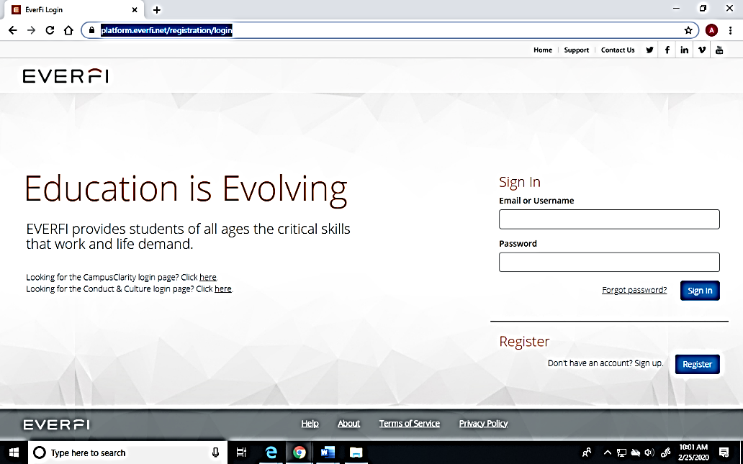

- Enter the Username and Password provided to you by Touch ‘Em All.
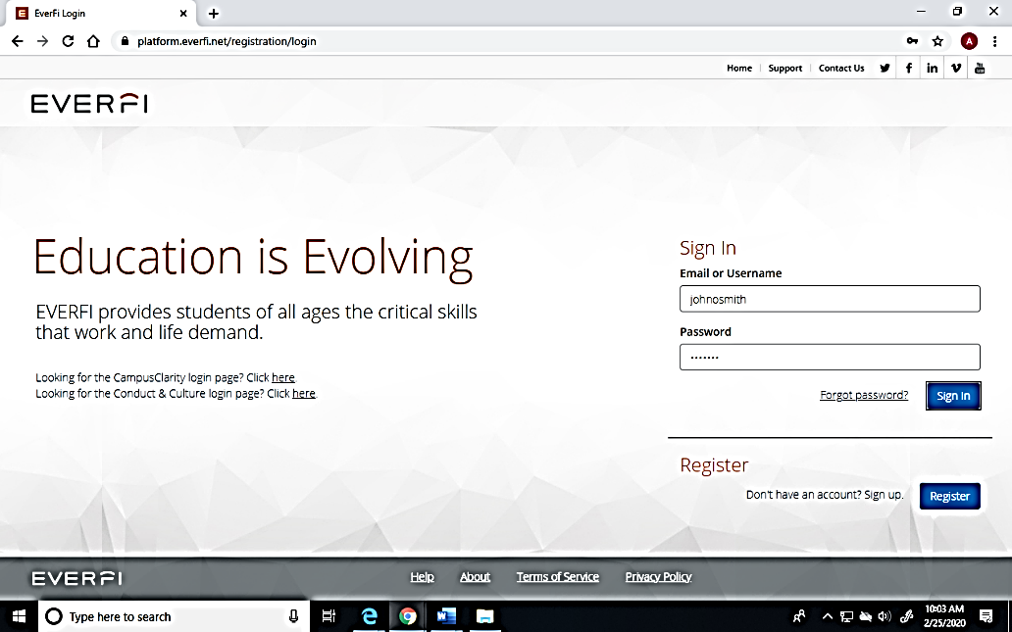

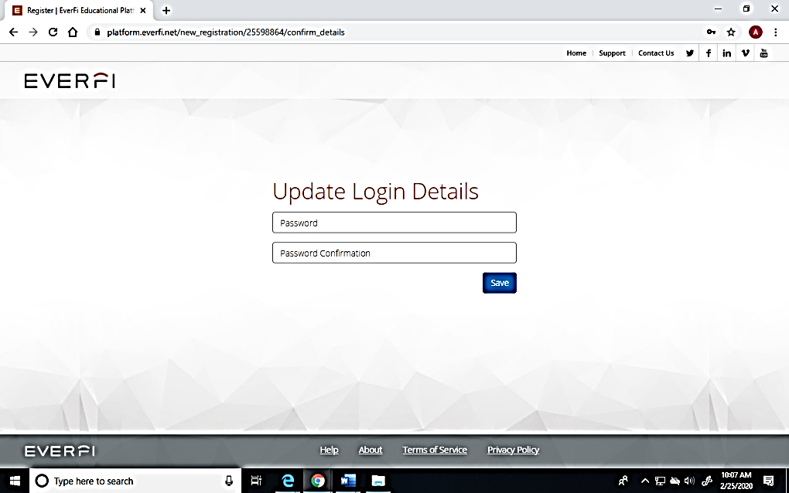
- You will be prompted to set your Permanent Password. (Please record Username/Password)

- You will then be directed to your individual page where you will see all EVERFI courses currently available to you.
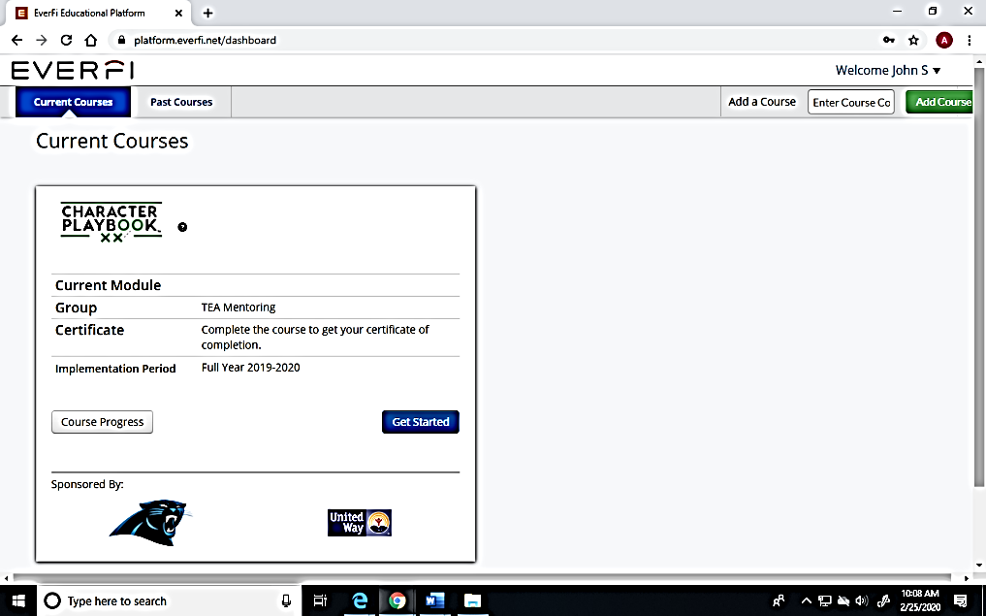

- You are all set!
- You can access your EVERFI account and modules at any time from any computer.
- Youth can complete the modules at their own pace.
- All modules are self-guided and age appropriate.
- Parents are encouraged to participate with their child as they are completing the modules. Ask questions and have your child discuss some of what they learned. It is a great conversation starter for the topics covered.
- Touch ‘Em All’s Mentoring Director Kelly Giles may communicate certain deadlines and incentives for completing certain modules.
- All modules require a post-assessment for completion.
- The score and time stamp for these post-assessments will be automatically sent to Touch ‘Em All. You do not have to print or save anything.

